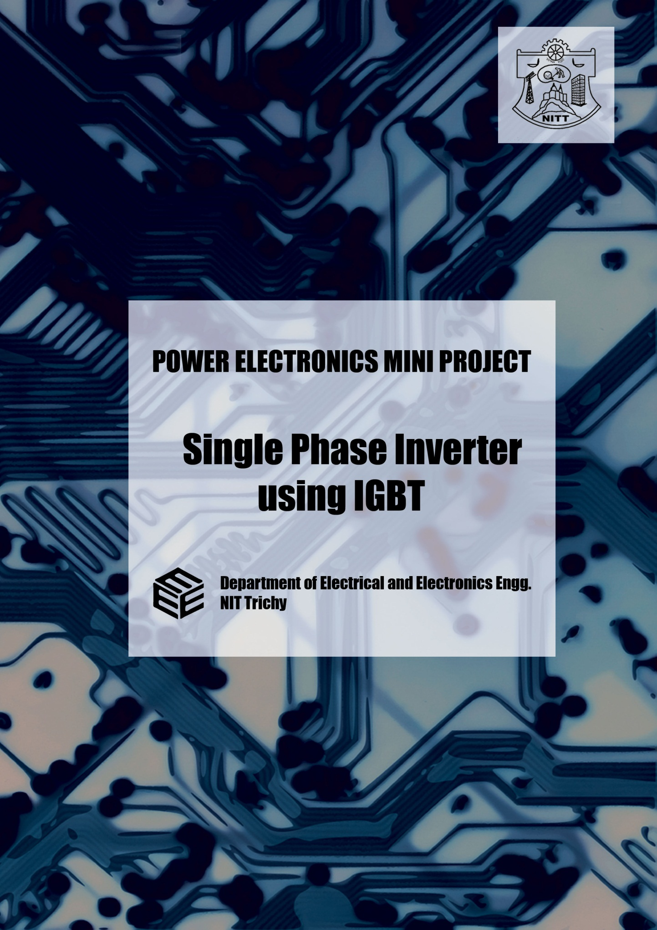

This is a report of the collective work done in the mini-project for

Power Electronics Laboratory

|  |  |  |
| --- | --- | --- |
| **S. No.** | **Name** | **Roll No.** |
| 1 | Govind Singh Rathore | 107108093 |
| 2 | Jasmeet Singh | 107108094 |
| 3 | Yash Prakash Kampoowale | 107108095 |
| 4 | Venkatakrishnan | 107108096 |
| 5 | Subramanian M K | 107108097 |
| 6 | Sai Aravinda Karthik | 107108098 |
| 7 | Sachin Jaiswal | 107108099 |
| 8 | Arjun Bhatia | 107108100 |
| 9 | Jainaveen S P | 107108101 |
| 10 | S Vignesh | 107108102 |
| 11 | Sambhav R Jain | 107108103 |
| 12 | Anup Srivatsan K R | 107108104 |
| 13 | Sandeep Rao V M | 107108105 |
| 14 | Surendra Kumar Tatwal | 107108106 |
| 15 | Arvind Bakodia | 107108107 |
| 16 | Karthik Balaji R | 107108109 |
| 17 | Thinakaran | 107108110 |
| 18 | Brajraj Meena | 107108111 |
| 19 | Gopal Karmakar | 107108112 |
| 20 | Shejram Meena | 107108113 |
| 21 | Pushpendra Singh Rawat | 107108001 |

Single Phase Inverter using IGBT

**Aim:**

To design and construct a single phase inverter using IGBTs, and thus to verify the principles and working behind its operation.

**Apparatus used:**

|  |  |  |  |
| --- | --- | --- | --- |
| **S. No.** | **Component** | **Specification** | **Quantity** |
| 1. | IGBT (FGA25N120ANTD) | 1200V | 4 |
| 2. | Monostable Multivibrator | DM74121N | 2 |
| 3. | Op-amp | IC741 | 1 |
| 4. | Hex Inverter IC | 74LS04 | 1 |
| 5. | Zener Diode | 5V | 1 |
| 6. | Quad 2-Input Exclusive-OR Gate | 74LS86 | 1 |
| 7. | Opto Isolator | MCT2E | 4 |
| 8. | Voltage Regulator | IC 7812 | 3 |
| 9. | Transformer | 230 / 6 V, 500mA  230 / 12 V, 500mA  230 / 12 V, 1A | 1  2  1 |
| 10. | Capacitor | 100 µF | 3 |
| 11. | Resistor | 220Ω, .25W  1k Ω, .5W  10Ω, 10W | 2  4  4 |
| 12. | Rectifier Diode | 1N4007 | 12 |
| 13. | DC RPS | - |  |
| 14. | Digital Storage Oscilloscope | - |  |
| 15. | Connecting Wires | - |  |

**Introduction:**

The main objective of static power converters is to produce an ac output waveform from a dc power supply. These are the types of waveforms required in adjustable speed drives (ASDs), uninterruptible power supplies (UPS), static VAR compensators, active filters, flexible AC transmission systems (FACTS), and voltage compensators. For sinusoidal ac outputs, the magnitude, frequency, and phase should be controllable. According to the type of ac output waveform, these topologies can be considered as voltage source inverters (VSIs), where the independently controlled ac output is a voltage waveform, or as current source inverters (CSIs), where the independently controlled ac output is a current waveform.

Single-phase voltage source inverters (VSIs) can be found as half-bridge and full-bridge topologies. Although the power range they cover is the low one, they are widely used in power supplies, single-phase UPSs, and currently to form elaborate high-power static power topologies, such as for instance, the multicell configurations.

**Theory:**

1. **Main circuit:**

A single phase bridge inverter is also known as voltage source inverter if it has the property of voltage control. The inverter circuit consist of four choppers. During the first half cycle, IGBT1 and IGBT2 are triggered with a gate pulse. During the next half cycle, gate pulses to IGBT1 and IGBT2 are removed and IGBT3 and IGBT4 are triggered. Thus the voltage waveform available at the load is a square wave. Since this type of triggering does not involve any kind of modulation, it is a simple square wave inverter. The output contains many harmonics and these can be reduced using various techniques like pulse width modulation, sinusoidal pulse width modulation and selective harmonic elimination.

Main Circuit:

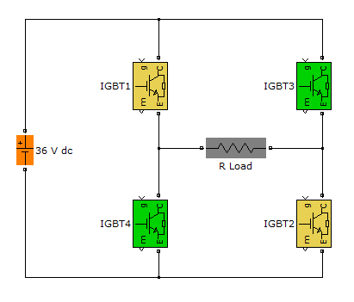

The nature of load current depends on the type of load. It is a scaled down replica of output voltage waveform for a resistive load; it lags the fundamental component of the load voltage for an inductive load. The lagging angle in latter case depends on the L/R ratio of the load. It rises exponentially like the current in series RL circuit which is initially connected to a battery for a small duration, and then falls when this battery is shorted for another interval. For a small duration after the voltage waveform changes polarity, the instantaneous current and voltage have been opposite signs, making the power negative.

This is because the inductive energy of the load, which increases when power is positive, is fed back to the dc source through the feedback diodes during the negative power condition. In view of the fact that zero crossings of the current waveform may occur anywhere in the half cycle depending on the L/R ratio of the load impedance, the triggering signals of the IGBT pairs should be rectangular pulses with sufficient duration.

1. **Firing Circuit:**

The firing circuit is one part of the single phase inverter in its entirety. This is a very crucial part of the circuit which has a complete hand on the operation of the fully controlled inverter. The firing circuit built here employs a 230V 1-phase ac supply for its operation. This ac supply is stepped down to 6V using a step-down transformer and is applied to the zero crossing detector (ZCD). This ZCD comprises of an op-amp comparator and two diodes to provide input protection at the input pins of the op-amp. When a zero-crossing is detected in the sinusoidal supply, the polarity of the output changes. Hence, the sinusoidal wave is converted into an alternating square wave.

Since this square is bipolar in nature and we do not require the negative part to be fed to the IGBT, we eliminate this negative part and retain the positive part alone. This is achieved using a diode across the output. The diode conducts for the negative half cycle, thereby allowing only the positive part of the square wave to pass through. Alternatively, a Zener diode can also be used.

This uni-polar square wave is used to trigger two of the 4 IGBTs used in the inverter circuit. For the other 2 IGBTs, we invert the square wave using a hex-inverter. However, a problem arises in this case. Due to the slew of the gate, there are instances where both pulses simultaneously trigger their respective IGBTs. This causes a short circuit that may prove to be detrimental to the hardware and the dc source. To avoid such a contingency, we use a blanking pulse to provide a dead-band at the edges during the time of triggering.

Firing Circuit:

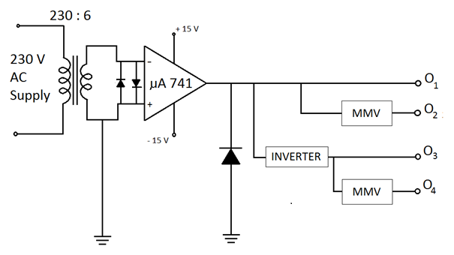

This blanking pulse is generated using a monostable multivibrator. Both the uni-polar square waves are used to trigger the respective multivibrators. This produces two blanking pulses, the first one of which is Ex-ORed with the first square wave and the second of which is Ex-ORed with the second square wave.

1. **Gate drive circuit:**

One notable flaw in this kind of arrangement is that all pulses are produced with respect to a common ground. i.e. that of the source. However, in order to trigger 4 IGBTs arranged in the form of a full bridge, we require gate drive signals with respect to different grounds. This problem mandates us to provide an isolation circuitry that is capable of providing multiple grounds.

There are two ways to achieve this isolation. The first is to use a pulse transformer. Since the pulse transformer works on the principle of electromagnetic induction, it provides electric isolation between the primary and secondary. But the pulse transformer has its own disadvantages. One is that the IGBT demands a continuous firing pulse unlike a pulse required by an SCR. Also, the pulse transformer consumes a lot of space due to its size. Due to all these constraints, a pulse transformer is not an ideal solution for this purpose.

Another solution is to employ opto-couplers. Optocouplers consist of a light transmitter and receiver pair. When a voltage is present in the input side, it converted to light of appropriate wavelength by the transmitter. This light is sensed by the receiver which replicates the input voltage. Hence, a continuous firing pulse is obtained unlike the pulse transformer. Above that, electrical isolation is also achieved. Hence, this arrangement of electrical isolation is preferred in circuits that employ IGBTs.

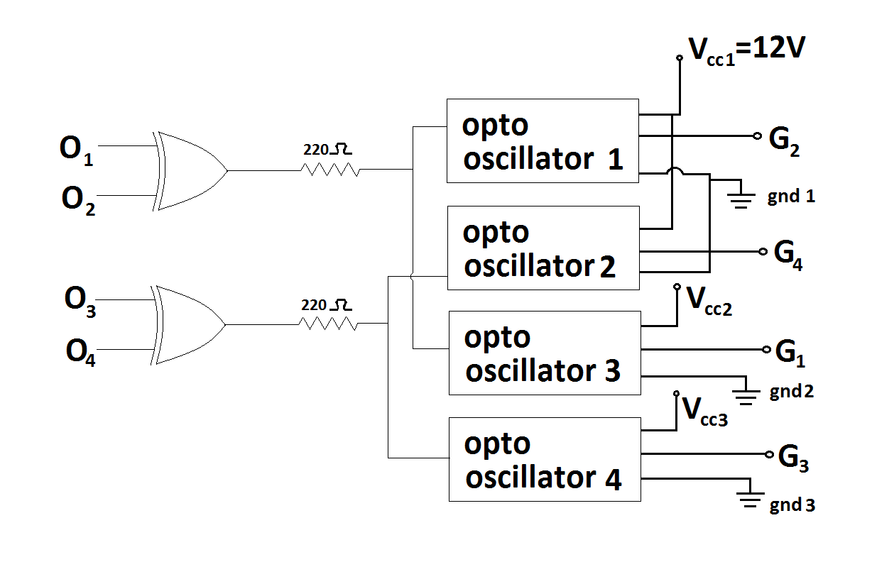Gate Drive Circuit:

**Applications:**

* **Backup power supply for household purposes**

This consists of a battery feeding an inverter circuit. The battery is charged when normal power supply is available, through an ac-dc rectifier circuit. Since the battery can only supply only dc voltage and most household appliances demand alternating supply, we employ an inverter.

However, the inverters used in households produce a sinusoidal waveform rather than a square wave being generated here. Sine wave inverters hold a definite advantage over square wave inverter since square wave consists of a sine wave and many harmonics. Due to these undesirable harmonics, there is a disturbance in the output, hence not living up to the performance of a pure sine-wave inverter. A square wave inverter can be employed as a sine wave inverter by passing the square wave inverter through a series of filters thus eliminating these detrimental harmonics.

* **Receiving end conversion of HVDC transmission systems**

HVDC transmission involves transmitting high dc voltages over hundreds of miles. DC voltages are transmitted to minimize losses. At the receiving end, however, a need arises to convert this dc voltage back to ac voltage to feed the distribution grid. The inverter comes into play here. At the receiving location, an inverter in a static inverter plant converts the power back to ac.

* **Variable frequency drives**

A variable-frequency drive controls the operating speed of an ac motor by controlling the frequency and voltage of the power supplied to the motor. An inverter provides the controlled power. In most cases, the variable-frequency drive includes a rectifier so that dc power for the inverter can be provided from main ac power. Since an inverter is the key component, variable-frequency drives are sometimes called inverter drives or just inverters.

* **Electric Vehicle Drives**

Adjustable speed motor control inverters are currently used to power the traction motors in some electric and diesel-electric rail vehicles as well as some battery electric vehicles and hybrid electric highway vehicles such as the Toyota Prius and Fisker Karma. Various improvements in inverter technology are being developed specifically for electric vehicle applications. In vehicles with regenerative braking, the inverter also takes power from the motor (now acting as a generator) and stores it in the batteries.

**Output waveforms:**

The switch in the simple inverter described above, when not coupled to an output transformer, produces a square voltage waveform due to its simple off and on nature as opposed to the sinusoidal waveform that is the usual waveform of an AC power supply. Using Fourier analysis, periodic waveforms are represented as the sum of an infinite series of sine waves. The sine wave that has the same frequency as the original waveform is called the fundamental component. The other sine waves, called harmonics that are included in the series have frequencies that are integral multiples of the fundamental frequency.

The quality of the inverter output waveform can be expressed by using the Fourier analysis data to calculate the total harmonic distortion (THD). The total harmonic distortion is the square root of the sum of the squares of the harmonic voltages divided by the fundamental voltage:

\mbox{THD} =  {\sqrt{V_2^2 + V_3^2 + V_4^2 + \cdots + V_n^2} \over V_1}


The quality of output waveform that is needed from an inverter depends on the characteristics of the connected load. Some loads need a nearly perfect sine wave voltage supply in order to work properly. Other loads may work quite well with a square wave voltage. In our case of single phase inverter, we obtain a total harmonic distortion of 48.01%.

1. **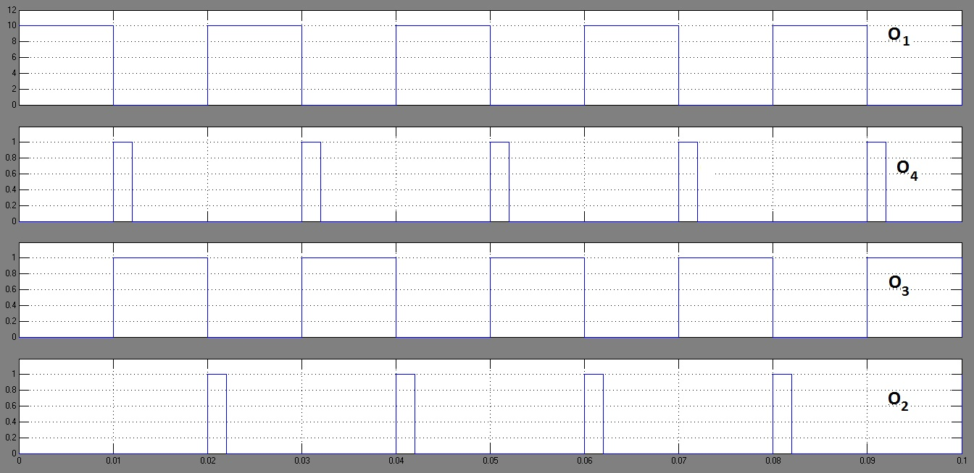Outputs O1, O2, O3, O4 :**

1. **Final gate pulses from the gate drive circuit:**

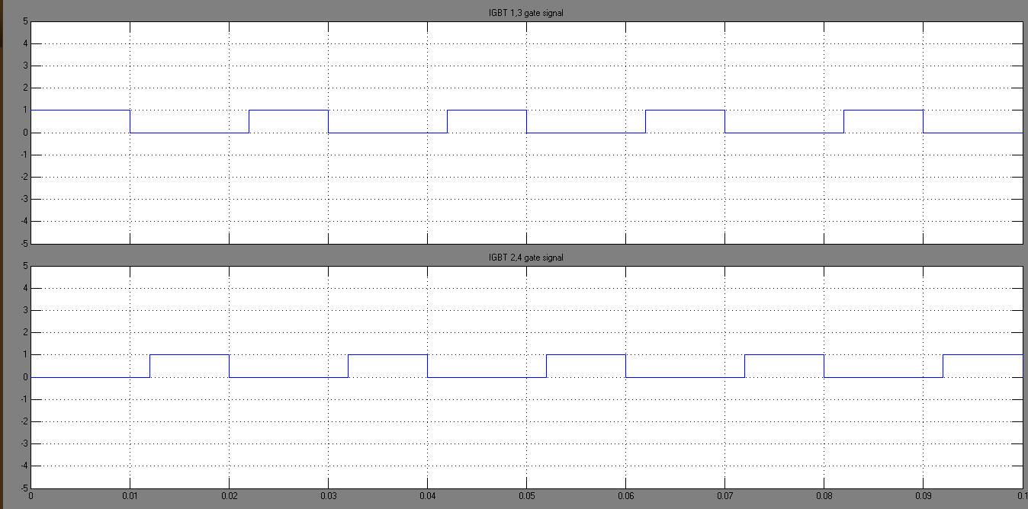

1. **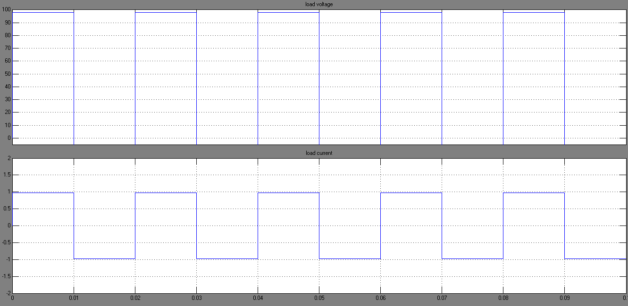Output at Load:**

**Results and Discussions:**

* Thus, a single phase inverter using IGBTs was successfully designed and constructed, and the principles and working behind its operation were verified and studied
* Further improvement in the THD can be achieved by using multiple pulse width modulation (MPWM) or sinusoidal pulse width modulation (SPWM) techniques to generate the firing pulses